**SQL ASSIGNMENT**

1. create database product details;
2. create table products; create table purchase_details;
3. 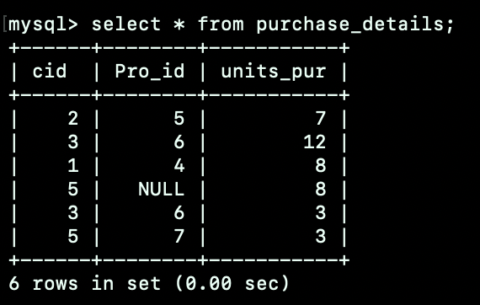Inserted values and then SELECT * FROM PRODUCTS; SELECT * FROM PURCHASE_DETAILS;

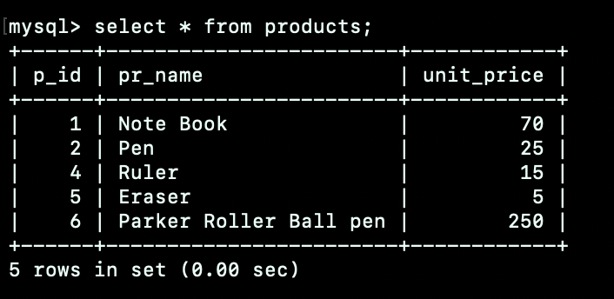

1. The value ends with pen

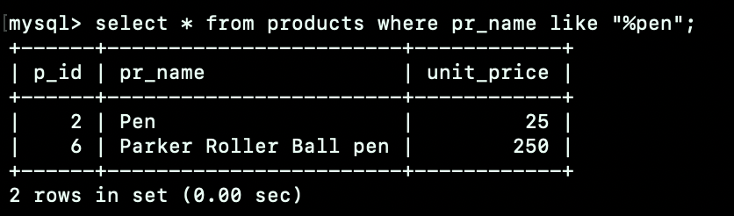

1. What is the max value from products table

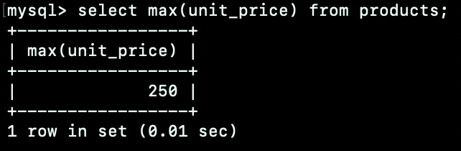

1. What is the average value of products

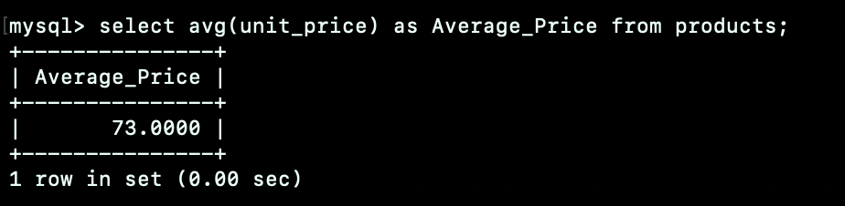

1. Give the details of products which has price greater than 100

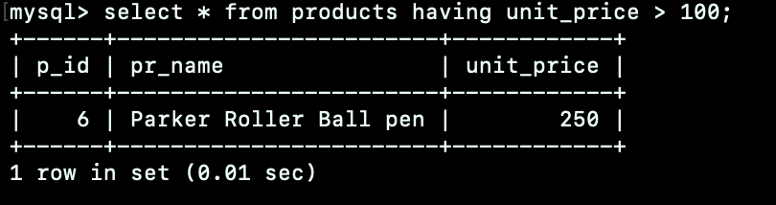

1. Arrange the product details in descending order

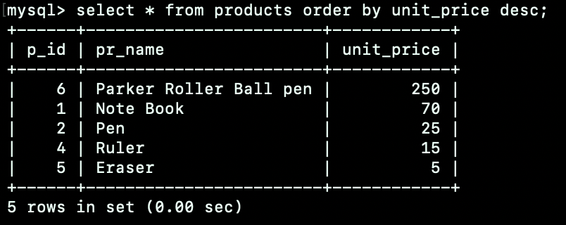

1. Inner join

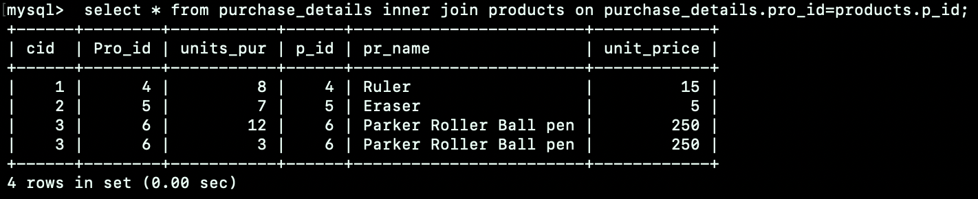

1. Left Join

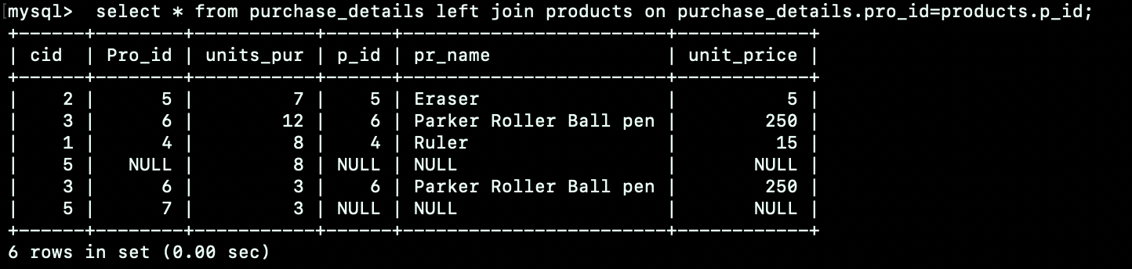

1. Left and right join

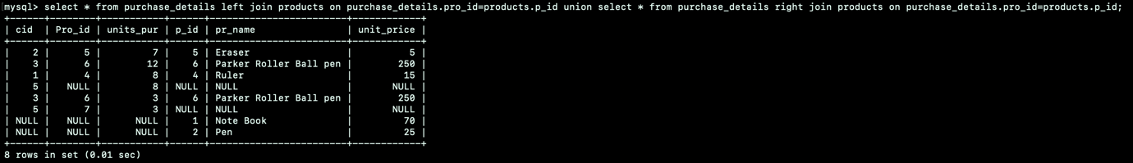

1. Right Join

